WSPML 2020 REGISTRATION FORM
2020 2nd International Workshop on Signal Processing and Machine Learning
Nov. 20-22
SECTION 1: BASIC INFO
*Full Name:  *Position:  *Email: | *Affiliation & Nationality:  *Mobile:  *Address & Zip Code (for postal use):

SECTION 2: AUTHOR INFORMATION
* Paper ID: * Paper Pages: * Additional Page(s):
* Paper Title:
* Authors:
* Presentation Terms √: Oral □ Poster □ Remote Video □ Video □

SECTION 3: REGISTRATION FEE
Category | Member | Nonmember | Student | One day program | Listener
Early Registration  (Until Aug. 22) | USD 460 | USD 510 | USD 430 | USD 360 | USD 260
Regular Registration  (Until Oct. 15) | USD 510 | USD 560 | USD 460 | USD 400 | USD 300
Late Registration  (After Oct. 15) | USD 560 | USD 590 | USD 490 | USD 430 | USD 350
Online Participation  (Until Nov.20) | USD 350 | USD 380 | USD 320 | USD 250 | USD 200

Extra Page / Per page | Extra Paper Upload
USD 50 | USD 250
*One regular paper is within 6 pages, including all figures, tables, and references. Extra pages will be charged for Additional Pages Fee. The length of long paper should not exceed 12 pages.
*All accepted papers will be published on-line.

Your Total Conference Fees
PAYMENT INFORMATION
Please calculate the amount of your registration fee and finish the payment with Online Payment link http://meeting.yizhifubj.com.cn/web/main.action?meetingId=475
Notice
Please make sure the conference organizer, HKSRA’s logo is always appear on the page until you submit your payment information. Next you will be directed to the payment page.
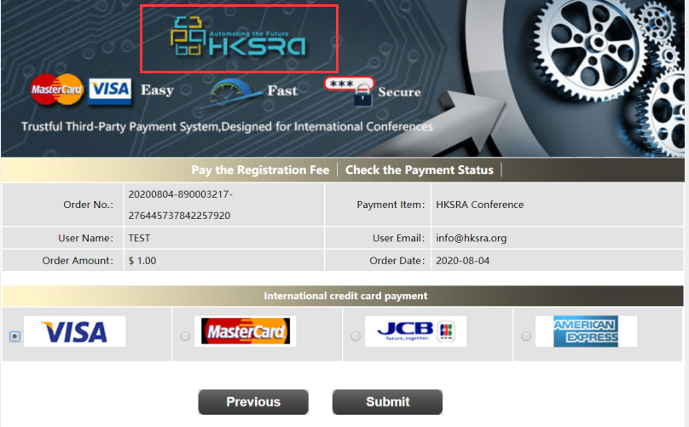

PAYMENT INFORMATION
Please fill in the following blanks after finishing your payment.
* Payment Email:
* Order No.
* Receipt Issued to:
Student ID No.(student only):
HKSRA Member No. (Member only):

SECTION 4: HKSRA MEMBER
HKSRA MEMBER APPLICATION: Join HKSRA now to qualify for member registration rates.
Please compile and return the Membership Form along with your CV to membership@hksra.org. Your application will be processed in 5 working days.

SECTION 5: OTHER
Please provide your one-inch photo for conference use.
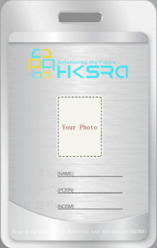
BIOGRAPHY: You are encouraged to write down a biographical sketch here, for the use of making introductions by Session Chair before your presentation. 20-120 Words(1-6.5 lines)

